LINUX PROGRAMMING: ASSIGNMENT-6: 20-09-2025
Submitted By : Urvija Kapila , 3C , Roll No: 11, ENG24CY0063

1. Which command is used to list the contents of a directory? Justify with proper example. (CO1)
Ans: “ls” command is used to list the contents of a directory.
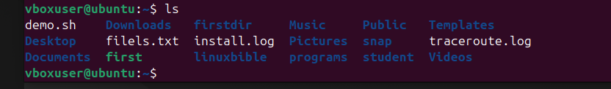

2. Write the command to create a new directory named 123test_dir. (CO1)
Ans: The command to create a new directory named 123test_dir is “mkdir”. It can be implemented as:
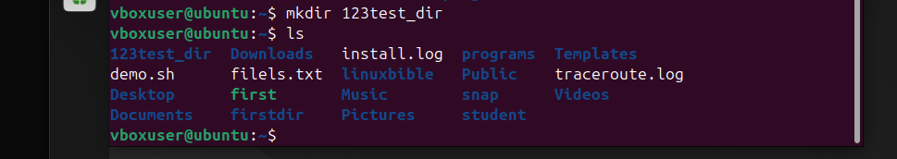
You can use the ls command to verify if the directory has been created.

3. What is the purpose of the sed command? Justify with proper example. (CO1)
Ans: The sed command in Linux stands for Stream Editor. Its purpose is to search, find, replace, insert, or delete text in a file or input stream — without manually opening the file. It’s especially useful for automating text processing tasks.
For Example : Replacing text
$ sed 's/Linux/Unix/' file.txt
This command will replace the first occurrence of the word Linux with Unix in each line of file.txt and display the result on the screen.

4. Which distinct command is used to display one-line descriptions of any commands? (CO1)
Ans: The “whatis” command is used to display one-line descriptions of any commands.
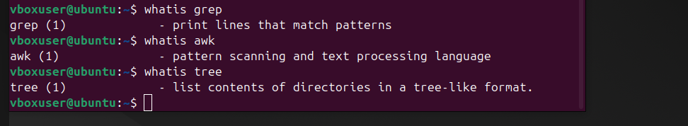

5. Write the command to create an empty file named “notes.txt”. (CO1)
Ans: the command to create an empty file named “notes.txt” can be written as : touch notes.txt
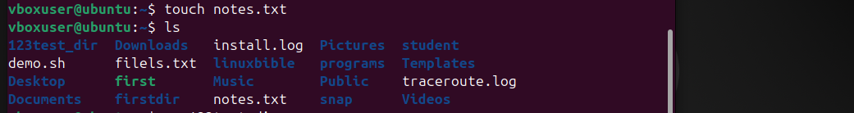

6. Differentiate between grep and awk commands with an example. (CO2)
Ans: The grep and awk commands in Linux are both powerful text-processing tools, but they serve different purposes. The grep command is primarily used for searching and filtering lines in a file that match a specific pattern or keyword. It simply displays the matching lines without modifying or analyzing the content. For example, grep "error" log.txt will display all lines from the file log.txt that contain the word “error.”
In contrast, the awk command is a pattern scanning and processing language used not only to search but also to analyze, format, and perform actions on text data. It treats each line as a record and divides it into fields, allowing advanced operations like calculations and formatting. For example, awk '{print $1, $3}' data.txt will print the first and third columns from data.txt.
In summary, while grep is best for simple searches, awk is more powerful for complex text processing and data extraction tasks.

7. Write the command to give read, write, and execute permission to the owner of a file script.sh. (CO1)
Ans: The command to give read, write, and execute permissions to the owner of a file named script.sh is:
$ chmod u+rwx script.sh
- chmod → changes file permissions.
- u → refers to the user (owner) of the file.
- +rwx → adds read (r), write (w), and execute (x) permissions.

8. How is chown different from chgrp? Give one example for each. (CO1)
Ans: The chown and chgrp commands in Linux are both used to change file ownership, but they affect different aspects of ownership.
The chown (change owner) command is used to change the owner of a file or directory. It can also change the group at the same time if specified. For example:
$ chown alice script.sh
This command changes the owner of the file script.sh to the user alice.
On the other hand, the chgrp (change group) command is used to change only the group ownership of a file or directory, without modifying the owner. For example:
$ chgrp developers script.sh
This command changes the group of script.sh to developers.

9. A user complains that they cannot execute a file even though it exists in their directory. How would you troubleshoot this using ls -l, chmod, and whoami? (CO3)
Ans: We can use the ls -l command to check the file’s permissions and ownership.
Then use the whoami command to verify the ownership or the current logged in user before granting special executable permissions.
And finally using chmod we can add execute permission ($ chmod u+x filename)

10. Design a command pipeline to: find all .log files modified in the last 2 days in /var/log, display them on screen, and save the results into a file recent_logs.txt using tee command. (CO4)
Ans: The command line for this action will be:
find /var/log -name "*.log" -mtime -2 | tee recent_logs.txt

